

DLD Lab-08

Encoder & Decoder



NATIONAL UNIVERSTIY OF COMPUTER AND EMERGING SCIENCES, FAST- Peshawar Campus

Department Of Computer Science

Instructor: Engr. Waseem Ullah

EL1005 – Digital Logic Design-Lab

SEMESTER SPRING 2022

Contents

1. Objectives: 2

2. Equipment Required: 2

3. Background Theory 2

1. Procedure 4

8. Encoders 4

9. Decoder 4

10. 2 to 4 Line Decoder 5

11. 3 to 8 Line Decoder 6

12. 3 to 8 Line Decoder Truth Table 6

13. Circuit Diagram of 3 to 8 Line Decoder 7

14. ENCODER 8

15. DECIMAL TO BCD ENCODER: 10

16. DECIMAL TO BCD ENCODER Circuit Diagram: 12

17. OCTAL TO BINARY ENCODER 12

18. Logic Diagram of Octal to Binary Encoder 14

# Objectives:

* Practicing the implementation of logic functions using MSI level functional blocks
* Gaining experience with MSI level functional blocks/components whose outputs are active low
* Gaining a close insight into the functioning and properties of decoder circuits
* Developing skills in the design and testing of combinational logic circuits.

# Equipment Required:

* DEV-2765E Trainer Board/ Multisim 14.2 /Logic.ly
* 74LS138 (3-to-8 Decoder)
* 74LS148 (8-bit Priority Binary Encoder)

# Background Theory

Decoder is used to convert code in to set of signals. Decoder is a multiple input, multiple output logic circuit that converts coded input into decoded output, where the input and output codes are different. The input code generally has fewer bits than the output, and there is one-to-one mapping, each input code word produces a different output signal. The most commonly used input code is an n-bit binary code, where an n-bit word represents one of 2n different coded values, i.e n-to-2n decoder or binary decoder.

Encoder is a logic circuit that has fewer output bits than the input code. The encoder takes 2n inputs bits and generates n-bit output. Only one of the inputs can be 1, and the corresponding binary will display on the output bits. But when more than one input bits become 1 at the same time then what should be the output then? So we give priority to inputs and the input with high priority will freeze the output with its binary value. Such an encoder is called *priority encoder*.

***Pin Configuration of 74LS138 (3-to-8 Decoder)***

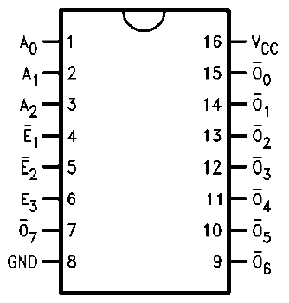

**74LS138**

Proper value at the enable lines (E1=0, E2=0, E3=1) will enable the decoder, all other combination of enable lines will keep the output lines high. These multiple enable lines are for building large decoders.

***TRUTH TABLE:***

|  |  |  |  |  |  |  |  |  |  |  |  |  |  |
| --- | --- | --- | --- | --- | --- | --- | --- | --- | --- | --- | --- | --- | --- |
| **Inputs** | | | | | | **Outputs** | | | | | | | |
| **E1** | **E2** | **E3** | **A0** | **A1** | **A2** | **O0** | **O1** | **O2** | **O3** | **O4** | **O5** | **O6** | **O7** |
| 1 | X | X | X | X | X |  |  |  |  |  |  |  |  |
| X | 1 | X | X | X | X |  |  |  |  |  |  |  |  |
| X | X | 0 | X | X | X |  |  |  |  |  |  |  |  |
| 0 | 0 | 1 | 0 | 0 | 0 |  |  |  |  |  |  |  |  |
| 0 | 0 | 1 | 1 | 0 | 0 |  |  |  |  |  |  |  |  |
| 0 | 0 | 1 | 0 | 1 | 0 |  |  |  |  |  |  |  |  |
| 0 | 0 | 1 | 1 | 1 | 0 |  |  |  |  |  |  |  |  |
| 0 | 0 | 1 | 0 | 0 | 1 |  |  |  |  |  |  |  |  |
| 0 | 0 | 1 | 1 | 0 | 1 |  |  |  |  |  |  |  |  |
| 0 | 0 | 1 | 0 | 1 | 1 |  |  |  |  |  |  |  |  |
| 0 | 0 | 1 | 1 | 1 | 1 |  |  |  |  |  |  |  |  |

# Procedure

1. Connect the trainer with the power supply
2. Install the IC 74LS138 on the trainer board
3. IC 74138 is a 3 to 8 decoder. Wire according to the diagram.
4. Use the logic switches for input and connect output O0 O1 ……O7 to the LEDs
5. Supply the VCC and GND to the pin 16 and 8 respectively
6. Test all the possible combination of input and fill out the table

# Encoders

Encoders and Decoders are combinational logic circuits.

An encoder is a device which transforms the data into some bits known only to it and the decoder is a device which transforms those coded bits to generate the original data again.

Encoding and Decoding is done for the safe transmission of data.

To encode something is to convert an unambiguous piece of information into a form of code that is not so clearly understood.

To decode is to perform the reverse operation: converting a code back into an unambiguous form.

The Main Difference between a decoder and encoder is that a decoder has

binary code as an input while an encoder has binary code as an output.

# Decoder

A decoder is a logic circuit that accepts a set of inputs that represents a binary number and activates only the output that corresponds to the input number.

In other words, a decoder circuit looks at its inputs, determines which binary number is present there, and activates the one output that corresponds to the number, all other outputs remain inactive.

A decoder is a circuit that changes a code into a set of signals.

In its general form, a decoder has N input lines to handle N bits and from one to 2^N output lines to indicate the presence of one or more N-bit combinations.

An AND gate can be used as the basic decoding element because it produces a high output only when all inputs are high.

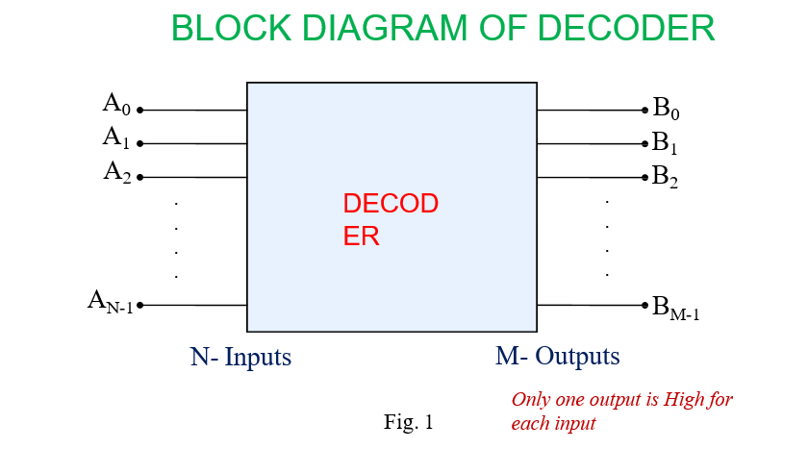

# 2 to 4 Line Decoder

* Block diagram of 2 to 4 decoder is shown in fig. 2
* A and B are the inputs. ( No. of inputs =2)
* No. of possible input combinations: 22=4
* No. of Outputs : 22=4, they are indicated by D0, D1, D2 and D3
* From the Truth Table it is clear that each output is “1” for only specific combination of inputs.

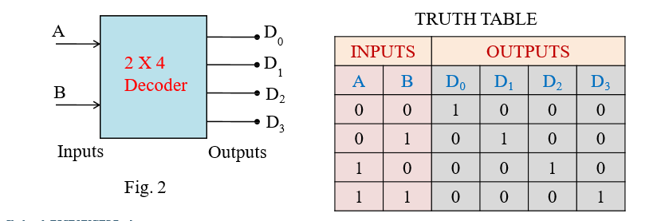

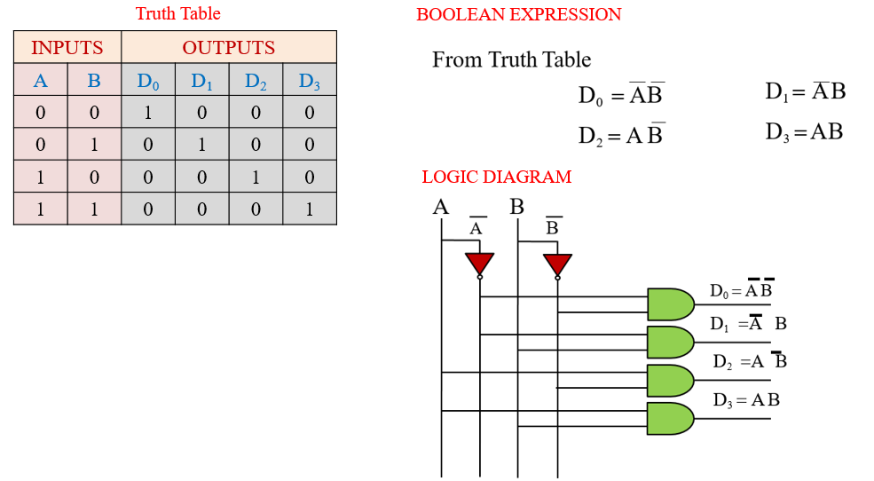

# 3 to 8 Line Decoder

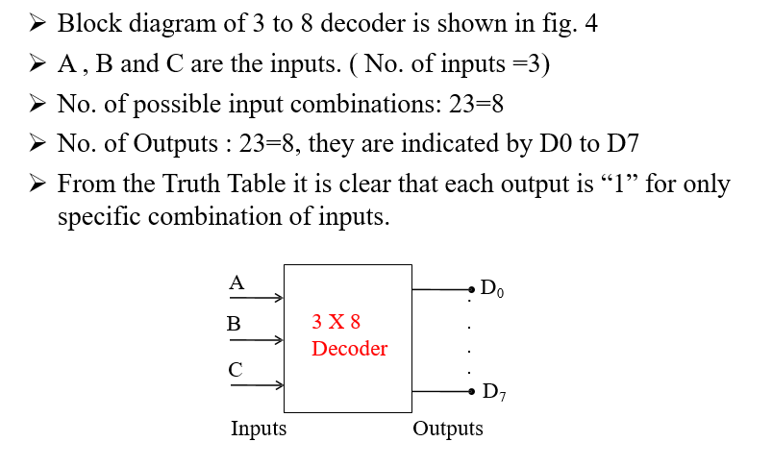

# 3 to 8 Line Decoder Truth Table

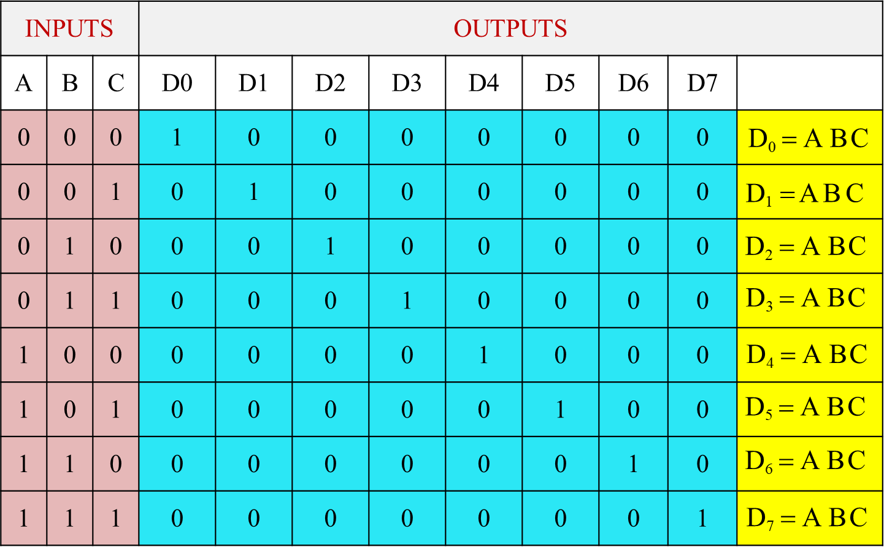

# Circuit Diagram of 3 to 8 Line Decoder

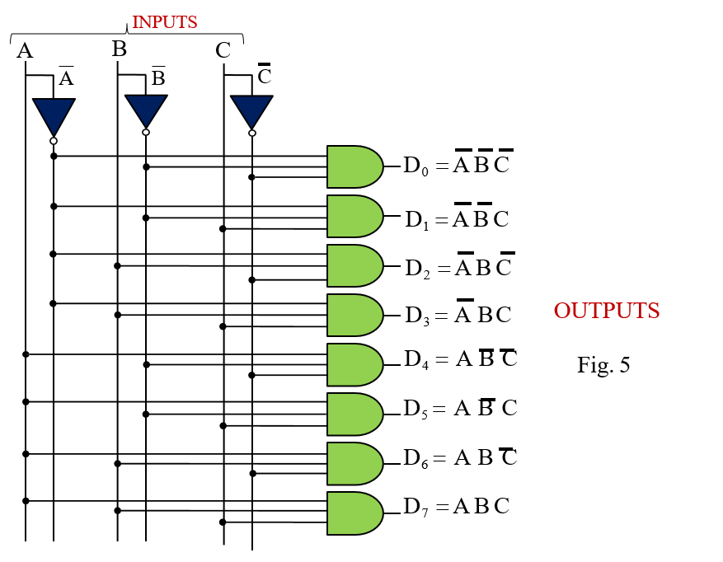

# ENCODER

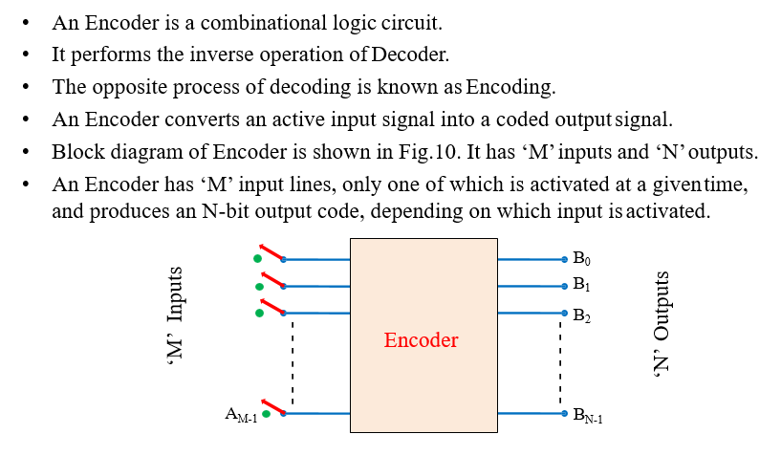

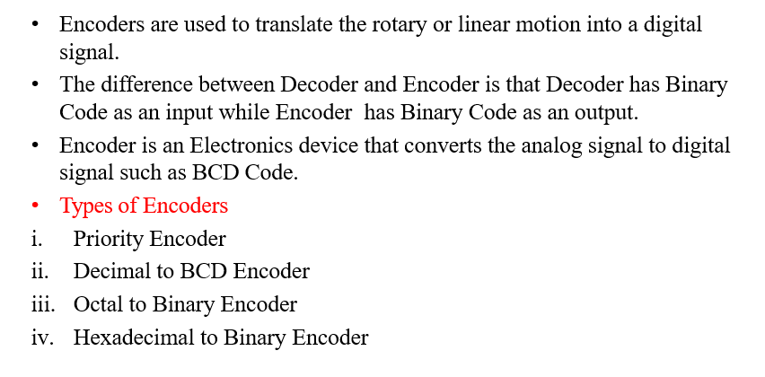

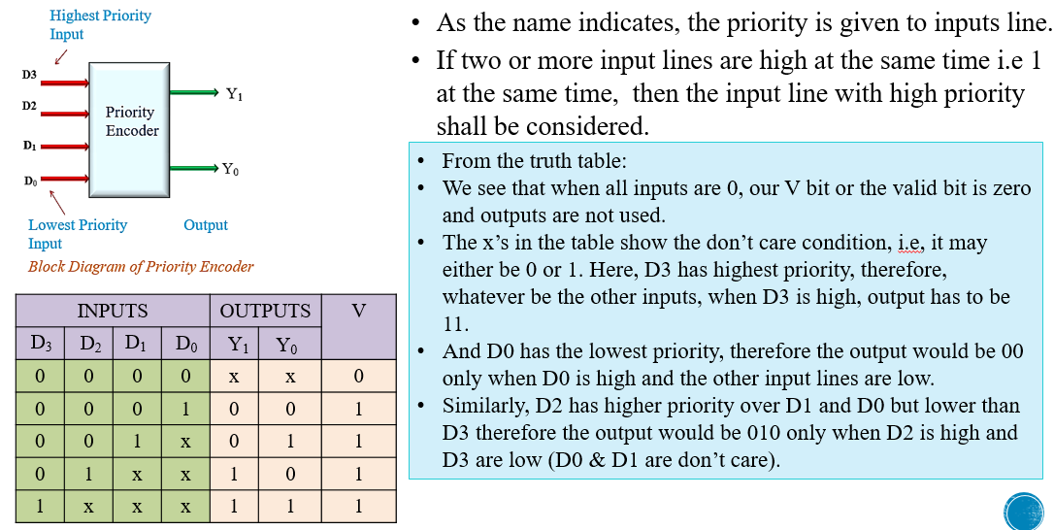

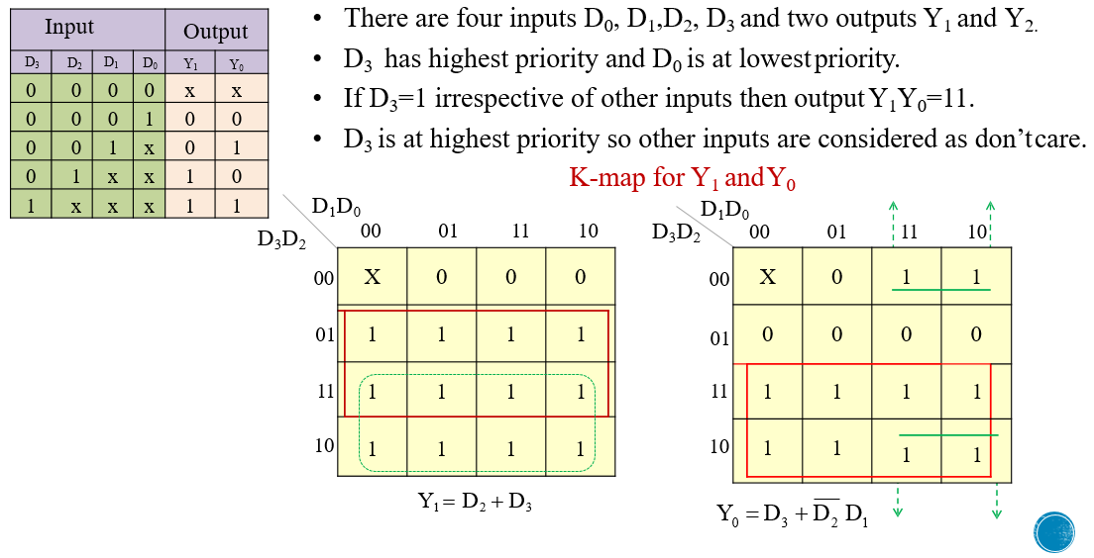

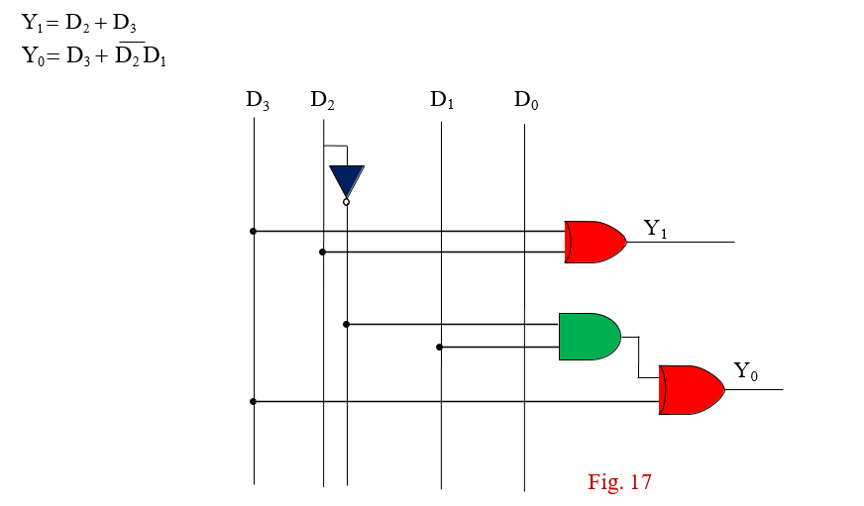

# DECIMAL TO BCD ENCODER:

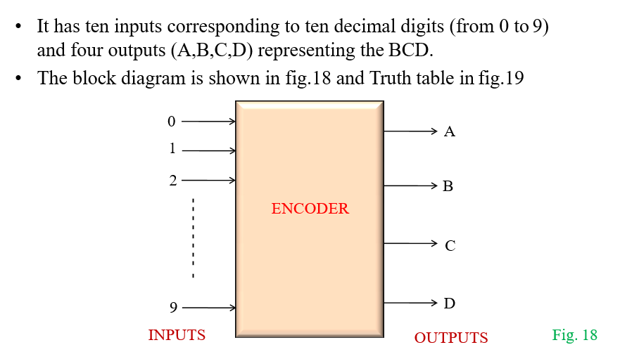

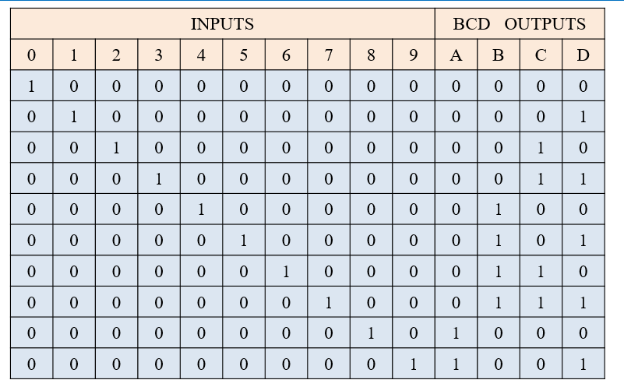

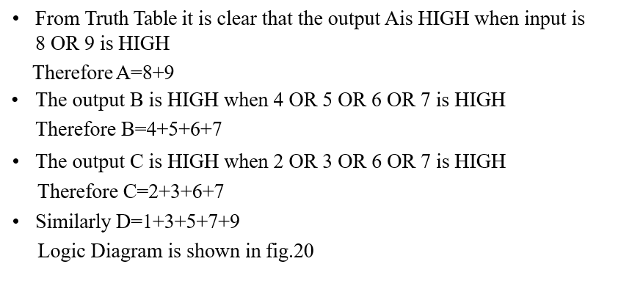

# DECIMAL TO BCD ENCODER Circuit Diagram:

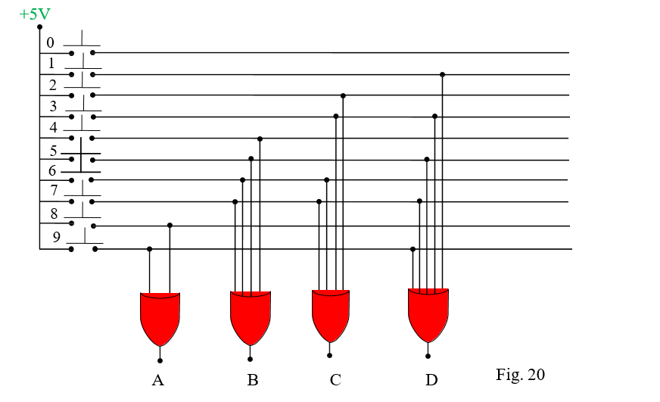

# OCTAL TO BINARY ENCODER

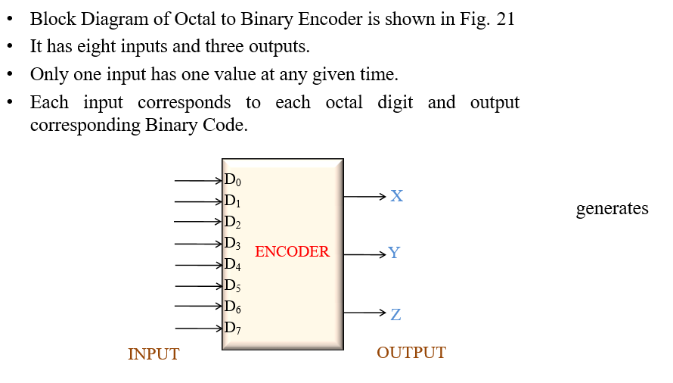

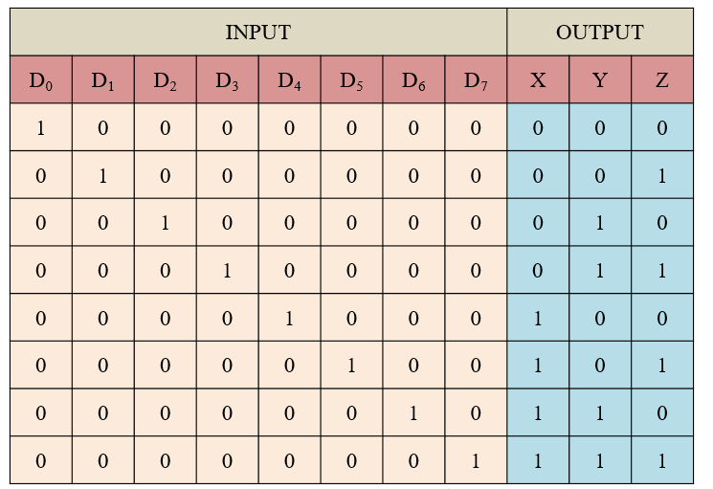

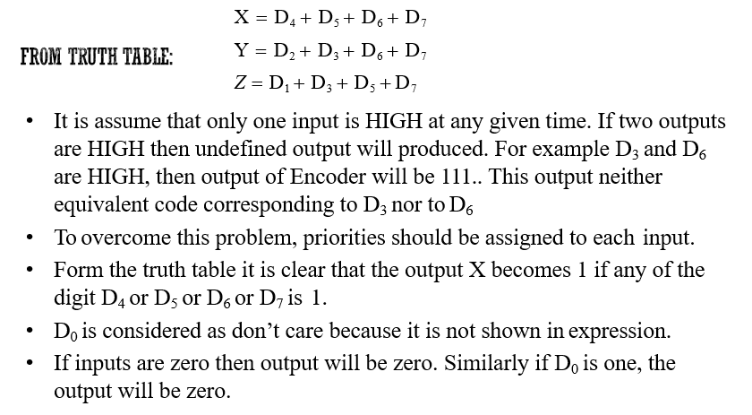

# Logic Diagram of Octal to Binary Encoder

